Abstract— The aim of the experiment was to assess how changing damping of a system affects certain qualities of oscillation especially when driven into resonance, such as Amplitude, Resonant Frequency, Phase Angle; and whether it complies with theoretical predictions. The system used was a torsion pendulum suspended in silicone oil acting as damping fluid with a motor providing driving frequency to the pendulum through a cam drive and chuck system. The results from this experiment agreed with predictions from theory wholly in all but one aspect.
Study of an Oscillating Mechanical System Driven into Resonance (21/12/2012)
Jubair Ahmed; Experiment performed with Thuvarakan Amirthamoorthy

Index Terms—Resonance, Damping, Frequency, Q-value

INTRODUCTION
Many forms of systems oscillate in “Simple Harmonic Motion” where the force required to return the system to equilibrium is directly proportional to the displacement of system from equilibrium. These experiments investigated how the effect of damping, removing energy from a system, aspects of oscillations within the system and ensure currently accepted theoretical suggestions are correct.
The theories referred to previously have been used for years and are generally accepted, however, there are many patterns, relations and resulting curves/graphs that have been procured and our intention to prove by testing them using our own SHM (Simple Harmonic Motion) system.
The experiments determined the effect of damping on the resonant frequency of the system. Another goal was to prove or disprove the accepted curve for phase difference between driven frequency and a varying driving frequency and also a curve relating effect of damping and frequency of driving force, on Amplitude. Curves mentioned, predicted by theory are shown in Fig. 1.
Theory predicts that at larger damping, amplitude of oscillation of the system is reduced. The effect resonance can be seen in Fig. 1 as the peak of the curves, resonance is when the driving frequency is close to the natural frequency of the system and oscillations have largest amplitude [1]; curves suggests the frequency of resonance decreases with larger damping. Theory also predicts that phase difference (between driven and driving frequency) changes more rapidly under lower damping.
Said experiments are important, the theory being tested is used to prevent damage to large, expensive buildings and infrastructure when being driven. Examples include large skyscrapers using oscillating masses suspension systems on bridges to ensure resonant frequency does not match the frequency of vibration that cars and people that use them produce. Inadequate usage of damping in above scenarios has led to well-known catastrophes.
SHM is also important in the study of the motion of atoms in solids and when bonded in chemical compounds and the effects of this and accurate theory allow enhanced modeling.
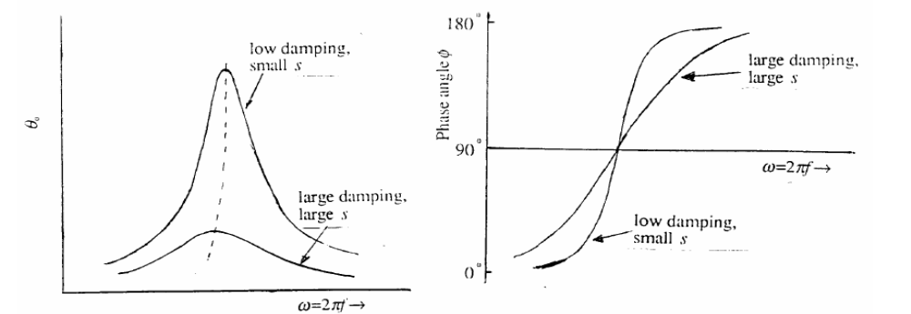
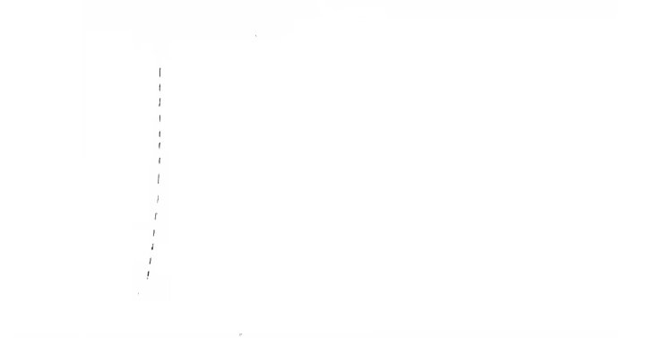

Figure 1 – First graph shows that at larger damping, amplitude of system’s oscillation is smaller whereas with low damping, amplitude is greater. It also shows, that at larger damping, frequency at which resonance is achieved is less than at lower damping. The second graph shows that at lower damping, the phase difference is much greater close to resonance compared to large damping.

The experiments performed had proved the curves taken to be the norm and have fulfilled all aspects being tested, mentioned above.
The experiment used a pendulum-bob submerged in damping fluid, silicone oil, with varying depth to change amount of damping. A motor of variable speed provided the varying driving frequency. A system of prisms and a laser tracked the oscillations of both the driving and driven frequency, a plotting table recorded the motion of the laser as ellipses.

Method

Apparatus
In this assembly, the motor powered a cam drive assembly connected to a chuck that applied an oscillation of small amplitude to the pendulum at the driving frequency of the motor via a torsion wire. The pendulum, as can be seen in Fig. 2 is within a plastic container which could be filled with variable amounts of silicone oil that provided the damping effect in this experiment. The angular frequency of driving frequency could be altered by changing the voltage provided to the motor and calculated through measuring the rotation of the cam drive.
Directly in front of the laser mount was the first prism that reflected light upwards onto the second prism, attached to the lever arm of the cam drive assembly. This then reflected light horizontally to a third prism attached on top of the pendulum which reflected it perpendicular towards the plotting table 80 cm away. This arrangement can be seen in Fig. 2

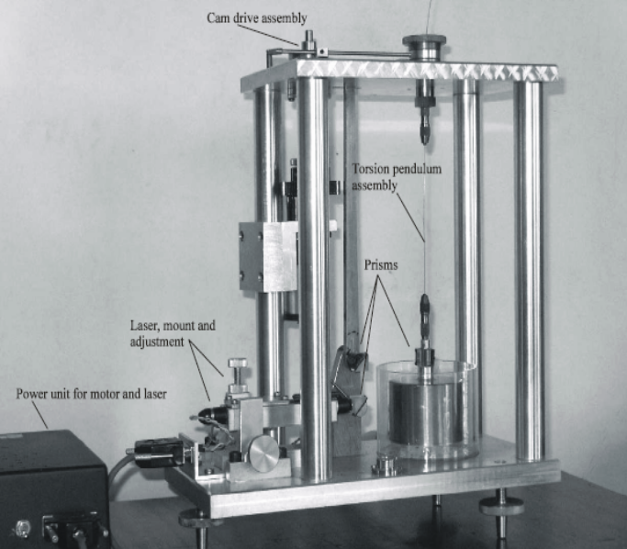
Figure 2 – This shows how to set up the apparatus for this experiment with laser in its mount, motor powering cam drive assembly, pendulum held by wire submerged in container with oil and prisms in correct places and alignments.

Motion of the cam drive assembly produced a back and forwards motion on the lever arm and the second prism; this produces the horizontal component of our ellipses from the driving frequency. The rotational motion of the pendulum and hence the third prism attached to it produced the vertical component of the ellipse formed which represented the driven frequency of the pendulum. This can be seen in Fig. 3 and 4.

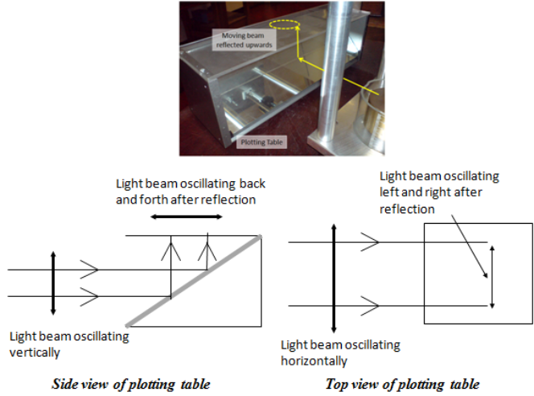
Figure 3 – Shows path of laser beam as it leaves third prism and plotting table perpendicular to laser beam. The system produces a circular/elliptical path on the table.

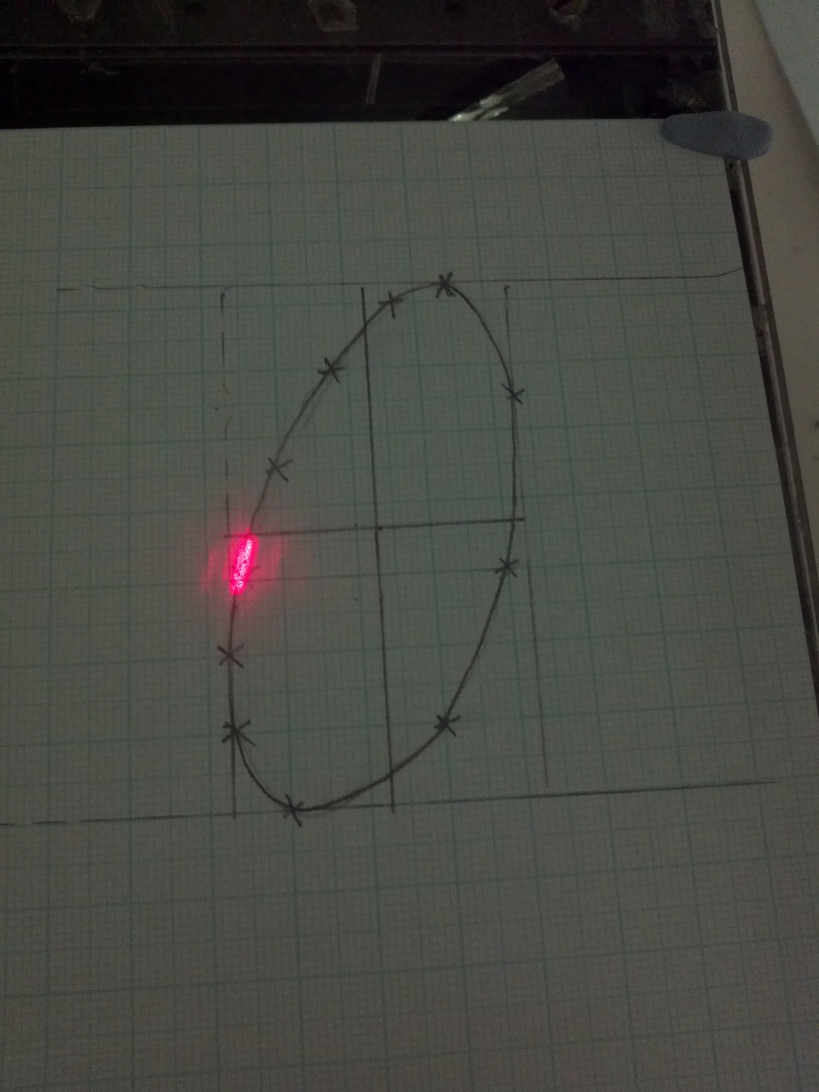
Figure 4 – Shows an ellipse formed by path of laser in a run of the experiment.

Procedures
At first, a damping level of 4 mm of silicone oil was used, then voltage of motor was changed and the system was allowed to reach equilibrium, the voltage was changed and the process repeated until resonance occurs; this is when the vertical height of ellipse formed, Amplitude, was greatest. The angular frequency at this point was measured by finding the Time period of ten oscillations, using a timer, then the mean from this and finally applying the equation:

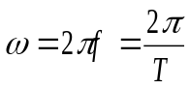
Multiple points on the ellipse (10-15 depending on ellipse sharpness) from the path of laser were plotted to allow accurate sketches of the ellipse.
(1)
Calculation of angular frequency and recording of ellipses was repeated for voltage readings of motor for 5 points above and 5 points below that of the resonant frequency found.
Then all steps were repeated again but at a larger damping of 25 mm, including finding frequency at resonance and acquiring ellipses for 5 points above and below.

Analyzing Ellipses
The ellipse had measurable lengths that were used to acquire data and then produce the curves required. After the ellipse has been sketched, measure the vertical distance from peak height and the lowest depth, which can be seen as the length, c to d, in Fig. 5. The midpoint of this length is where the x-axis lies. To find the y-axis, measure the horizontal distance between the rightmost and leftmost points of ellipse, the midpoint of this is where the y-axis lies. This length between the two intercepts of the y-axis of the ellipse gives you the length a to b as seen in Fig. 5.

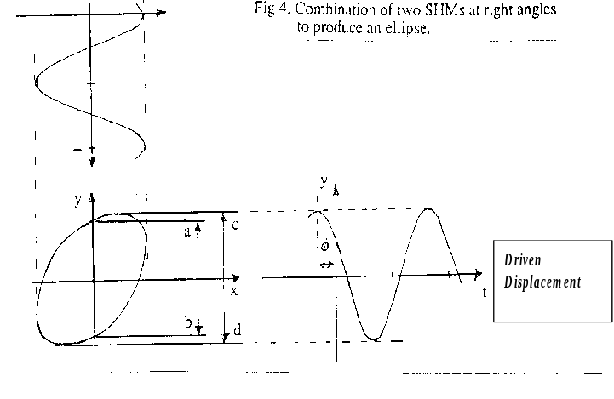
Figure 5 – This shows an example of the ellipse formed and the lengths measured from it.

(Multiple ellipses can be drawn on a single set of as the axis do not change, but do not sketch more than 6 on one set of axis as it becomes unclear).
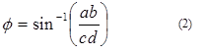
The ellipse formed is a superimposing of curves formed from 2 different sources, both SHM, driving frequency and driven frequency orthogonal to each other. So the equation:

can relate the two measured lengths and acquire the phase difference between the two sources.
The skew or direction of the ellipse also affects the phase angle, or which quadrant the phase angle is in. The ellipse in figure 5 is skewed to the right so the angle is less than 90°; but if skewed to the left, the angle would be in the second quadrant, so between 90° to 180°. (This is especially important to note when producing the curves).

Additional Points
Ensure all apparatus including laser mount equipment and plotting table is level, using spirit and plumb levels. Affix all equipment in place to prevent voiding results due to distance between prisms and plotting table changing, affecting amplitudes acquired.

Results

Curves
The curves obtained from data collected, Fig. 6 and 7, were near identical to the curves predicted by theory, however, the intercept in the Phase Angle vs Angular Frequency curves for the two different damping levels intercepted at 105° rather than 90°.

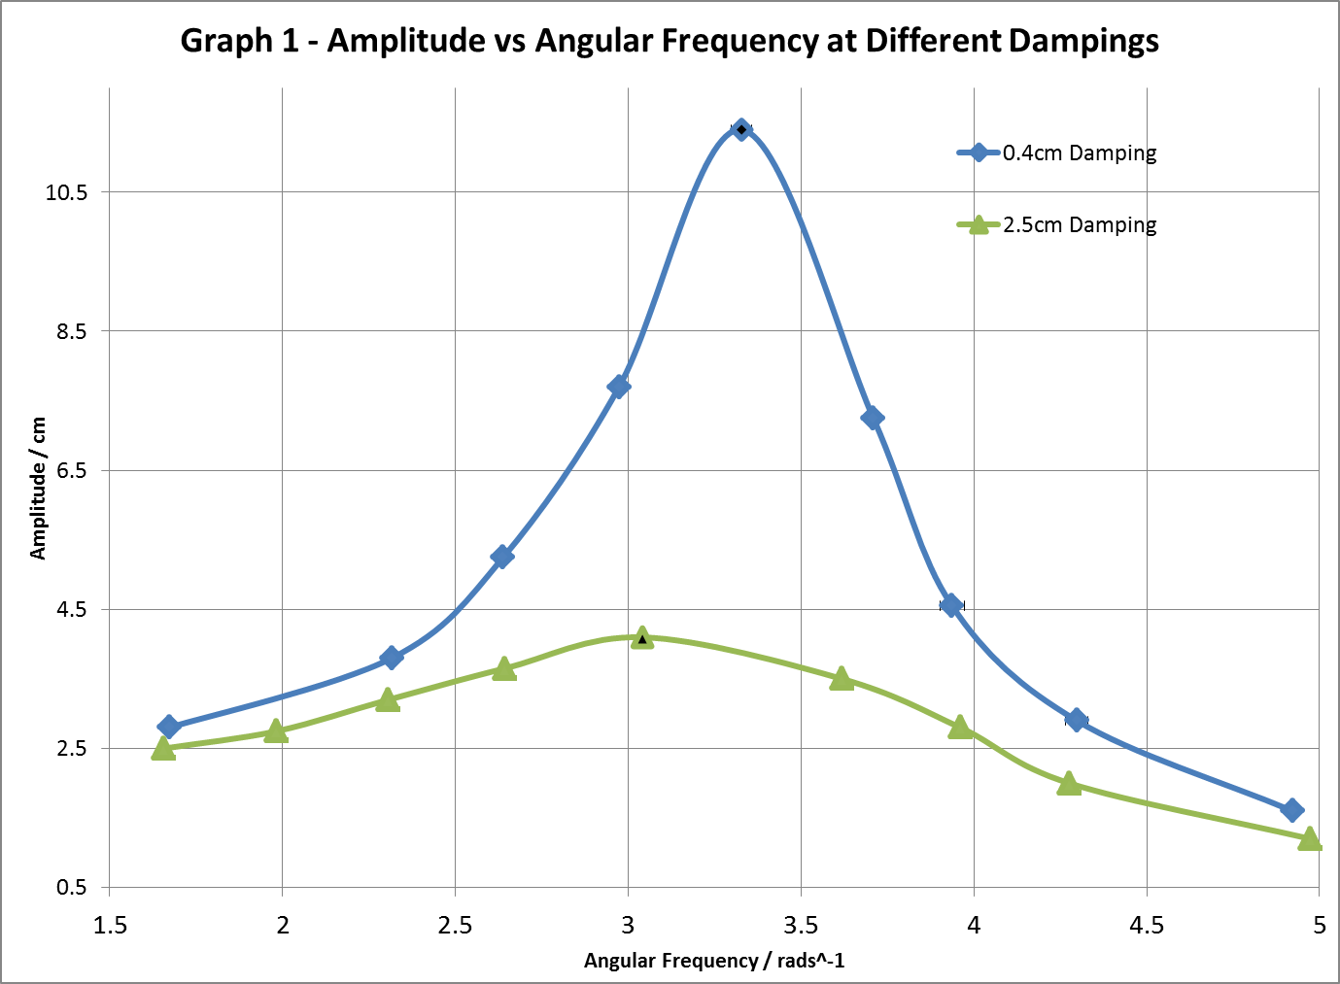
Figure 6 – This graph shows the curves for Angular Frequency vs Amplitude tested at the two damping levels 4 mm and 25 mm.

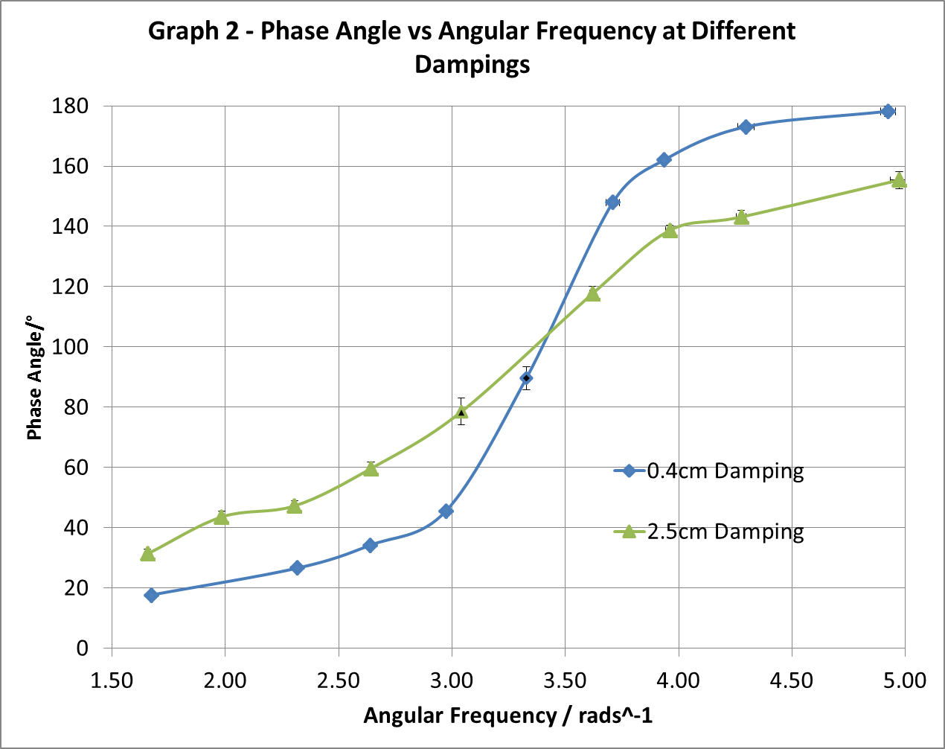
Figure 7 – This graph shows curves for Angular Frequency vs Phase Angle tested at the two damping levels of 4 mm and 25 mm.

Analysis of Curves
Analyzing Fig. 6, the resonant amplitude of the system at 4 mm damping was (11.4 ± 0.1) cm and resonant amplitude at 25 mm of damping was (4.1 ± 0.1) cm. Thus, at larger damping, amplitude at resonance is reduced. The curves also indicated that amplitude is reduced by larger damping at angular frequencies other than at resonance, but at very fast or very slow rotations, the difference in amplitude at both levels of damping is minimal.
The graph also showed that larger damping reduced the angular frequency at which resonance occurs. At 4 mm damping, resonance occurred at (3.3 ± 0.1) rads⁻¹, and at larger damping of 25 mm, resonance occurred at (3.0 ± 0.1) rads⁻¹.
Figure 7 showed that the phase difference between driving frequency and driven frequency is larger under lower damping when close to resonance. However, the magnitude of this difference decreases as angular frequency becomes very small or very large. Phase Angle at resonance when under 4 mm of damping is (90 ± 4)° and is (78 ± 4)° under 25 mm of damping. The theoretical results predict that phase angle at resonance should always be 90°. The acquired results for phase difference at resonance (for 25 mm damping) contradicts what the theory suggests and has to be scrutinized further.

Q-Values
Q-Value is a measure of the sharpness of a curve; it is acquired by using the formula:
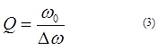

In this formula, ω₀ represents the peak value of Angular Frequency of curve, which was equivalent to Angular Frequency at Resonance. Δω is the width of resonance curve between values for Angular Frequency whose amplitude is reduced by √2 of peak Amplitude [2].
The Q-Value for curve at 4 mm damping was calculated as (22.80 ± 0.06) and (1.80 ± 0.10) for curve at 25 mm damping. (Q-Values have no units). The results showed Q-Values decrease as damping is larger, therefore, curves for low damping will be steep and sharp, whereas curves for large damping will be shallow and with very gradual incline.

Uncertainties
Sources of uncertainty that affected data included measurement of lengths of ellipse which is accurate to only the measuring tool being used, a standard ruler, and the accuracy of sketching the ellipse. Also relevant was uncertainty in measuring of Time Period, this was minimized through measuring 10 oscillations rather than one, repeating this thrice and then finding mean; standard deviation from the mean was used as uncertainty in this measurement.
These uncertainties were then propagated through to find the uncertainties in Angular Frequency and Phase Angle; uncertainties are included in Fig. 6 and 7, as error bars but are very difficult to see.
Other uncertainties include that of measurement of level of damping, distance to plotting table and voltage applied to motor; these are not significant in the scope of these experiments.
The Uncertainties calculated were very small which indicated the quality of method used in experiment.

Conclusion
The results obtained strongly agree with what existing theory predicts including the relation between Amplitude and Damping, Resonant Frequency and Damping, Q-Value with Damping and Phase Angle with Angular Frequency. What this proves is that the currently accepted theory is correct and expected results are produced when actually being used in a real, physical example and hence other system should respond similarly.
The one aspect that did not fit with the accepted theory was the phase angle at resonance at higher damping which was not the accepted 90°. I could not find a systematic error that may have led to this; therefore it may be due to a random error in that specific run of the experiment or may have actually been correct. I recommend performing an experiment for finding phase angle at resonance using the same experimental set-up with at least 5 different levels of damping to find if there was a random error or if large damping does actually change resonant frequency.
I believe that at very large damping resonant frequency should be decreased noticeably and the recommended experiment above could be of importance.
References
- Physics for Scientists and Engineers, R. A Serway; J. W. Jewett,8th Ed., 2010, Pg. 453
- Experiment NX3 Script, Dr. Paul Bartlett, 03/09/2012, Pg.8
Fig. 1 Experiment NX3 Script, Dr. Paul Bartlett, 03/09/2012, Pg.7
Fig. 2 Experiment NX3 Script, Dr. Paul Bartlett, 03/09/2012, Pg.8
Fig. 3 Experiment NX3 Script, Dr. Paul Bartlett, 03/09/2012, Pg.10
Fig. 5 Experiment NX3 Script, Dr. Paul Bartlett, 03/09/2012, Pg.11

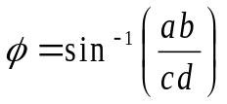
(2)

 .

